Doblò 1.3 JTD E.G.R. - VALVE HEAT EXCHANGER ASSEMBLY - Connector PIPES - R.R. 1080C82

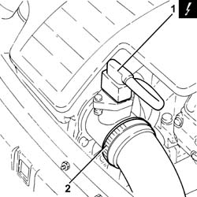 | Removing ( Refitting )  Position the car on the ramp.  Ensure that the ignition key is in the OFF position, then disconnect the negative battery terminal.  Carry out - 5530B10 battery - r+r .  Carry out - 5530B52 Battery DRIP TRAY/SUPPORT - R.R. .  1. Disconnect the electrical connection from the air flow meter.  2. Loosen the band and disconnect the the turbocharger air inlet sleeve from the rigid pipe, air flow meter side.
   | Name | Connector
  - | Battery | A1H
   | Name | Connector
  1 | Air flow meter | K41

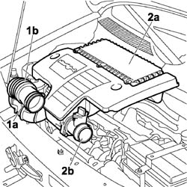 | 1. Loosen the band (1a) and disconnect the flexible hose (1b) from the air intake.  2. Remove the air filter (2a) complete with air flow meter (2b) by releasing from the underlying pins and then from the rear fastenings.

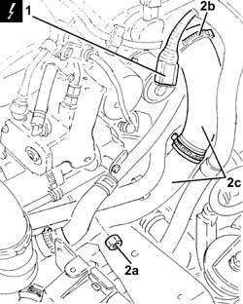 | Carry out - 7055B54 under-engine guard - r r .  Carry out - 0010T20 coolant change .  1. Disconnect the electrical connection from the E.G.R. valve.  2. Undo the nut (2a), loosen the band (2b), then disconnect the heat exchanger air supply pipe to the inlet manifold (2c), inlet manifold side, and move it aside.
   | Name | Connector
  1 | EGR solenoid | L30

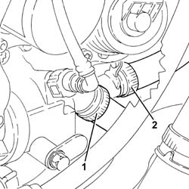 | 1. Loosen the band and disconnect the coolant supply pipe to the water/exhaust gas heat exchanger for the E.G.R. system, thermostat side.  2. Loosen the band and disconnect the coolant supply from the water/exhaust gas heat exchanger for the E.G.R. system to the climate control system heater, heat exchanger side.

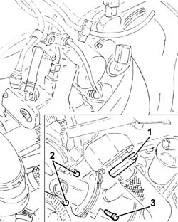 | 1. Loosen the collar securing the exhaust gas/water heat exchanger for E.G.R. system, inlet manifold side.  2. Undo the bolts securing the E.G.R. valve/heat exchanger assembly to the cylinder head.  3. Undo the bolt securing the E.G.R. valve/heat exchanger assembly to the engine block.

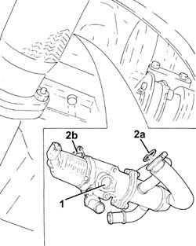 | 1. Working from under the car, remove the E.G.R. valve/heat exchanger assembly and connecting pipes.  2. Remove the gaskets (2a) and (2b).

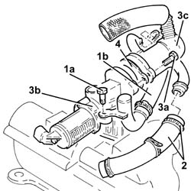 | Position the E.G.R. valve/heat exchanger assembly and connecting pipes in a vice fitted with protective jaws.  1. Undo the bolt (1a), loosen the band and remove the coolant outlet pipe (1b) from the exhaust gas/water heat exchanger for E.G.R. system.  2. Loosen the band and remove the coolant inlet pipe to the exhaust gas/water heat exchanger for E.G.R. system.  3. Undo the bolts (3a) and detach the E.G.R. solenoid (3b) from the exhaust gas/water heat exchanger for E.G.R. system (3c).  4. Remove the gasket.

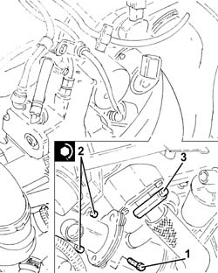 | Refitting ( Removing )  Assemble the E.G.R. solenoid to the exhaust gas/water heat exchanger for E.G.R. system after fitting the gasket and tightening the bolts.  Refit in its seating the coolant inlet pipe to the exhaust gas/water heat exchanger for E.G.R. system and tighten the band.  Refit in its seating the coolant outlet pipe from the exhaust gas/water heat exchanger for E.G.R. system, then secure it with the band and bolt.  Remove the E.G.R. valve/heat exchanger assembly and connecting pipes from the vice.  Working under the vehicle, refit in its seating the E.G.R. valve/heat exchanger assembly and connecting pipes complete with gaskets.  1. Tighten the bolt securing the E.G.R. valve/heat exchanger assembly to the engine block.  2. Tighten the bolts securing the E.G.R. valve/heat exchanger assembly to the cylinder head.  3. Tighten the collar securing the exhaust gas/water heat exchanger for E.G.R. system, inlet manifold side.
   | Fastening | Component | Ø | Value  (daNm)
  2 | Bolt | E.G.R EXHAUST GAS HEAT EXCHANGER. | M8 | (Cylinder head side) 2.0 ÷ 2.4

Connect the coolant supply pipe from the exhaust gas/water heat exchanger for E.G.R. system to the climate control system heater, heat exchanger side, and tighten the band.
Connect the engine coolant supply pipe to the EGR system water/exhaust gas heat exchanger, thermostat side and tighten the band.
Connect the air supply pipe from the heat exchanger to the inlet manifold, inlet manifold side, then tighten the band and nut.
Connect the electrical connection to the EGR solenoid.
 | Name | Connector
- | EGR solenoid | L30
Position in its seating the air filter complete with air flow meter, engaging it in the rear attachment and then in the underlying pins.
Connect the hose to the air intake on the crossmember and tighten the fixing band.
Connect the air intake sleeve to the turbocharger, air flow meter side, and tighten the band.
Connect the electrical connection to the air flow meter.
 | Name | Connector
- | Air flow meter | K41
Carry out - 5530B52 Battery DRIP TRAY/SUPPORT - R.R. .
Carry out - 5530B10 battery - r+r .
Connect the battery negative terminal.
 | Name | Connector
- | Battery | A1H
Refill the engine cooling system with coolant - 0010T20 coolant change .
Carry out - 7055B54 under-engine guard - r r .
Remove the car from the ramps.

